DAYANANDA SAGAR UNIVERSITY

**KUDLU GATE, BANGALORE – 560068**



**Bachelor of Technology   
  
in**

**COMPUTER SCIENCE AND TECHNOLOGY**

**Project Phase-II Report**

**(20CT4802)**

**IoT-Enhanced Tomato plant cultivation with machine learning**

By

**ABHAS AGNIHOTRI - ENG20CT0001**

**DEEPAK B G - ENG20CT0009  
M NIKHIL GUPTHA - ENG20CT0015**

**SHASHIKALA M S - ENG20CT0025**

**Under the supervision of  
  
NIVETHA NRP,  
Assistant Professor**

**Department of Computer Science and Technology**



**Department of Computer Science & Technology**

Kudlu Gate, Bangalore – 560068 Karnataka, India

**CERTIFICATE**

This is to certify that the work titled **“ IoT-Enhanced Tomato plant cultivation with machine learning”** is carried out by **Abhas Agnihotri (ENG20CT0001), Deepak B G (ENG20CT0009), M Nikhil Guptha (ENG20CT0015), Shashikala M S (ENG20CT0025)** Bonafide students of Bachelor of Technology in Computer Science and Technology at the School of Engineering, Dayananda Sagar University, Bangalore in partial fulfillment for the award of degree in Bachelor of Technology in Computer Science and Technology, during the year **2023-2024**.

___________________________ __________________________

**Prof. Nivetha NRP Dr. M Shahina Parveen**

Associate Professor, Dept. of CST Chairperson, Dept. of CST,

School of Engineering, School of Engineering,

Dayananda Sagar University. Dayananda Sagar University.



**Department of Computer Science & Technology**

Kudlu Gate, Bangalore – 560068 Karnataka, India

**DECLARATION**

WeAbhas Agnihotri (ENG20CT0001), Deepak B G (ENG20CT0009), M Nikhil Guptha (ENG20CT0015), Shashikala M S (ENG20CT0025) ,are students of the seventh semester B.Tech in Computer Science and Technology, at School of Engineering, Dayananda Sagar University, hereby declare that the project phase-II project titled “ IoT-Enhanced Tomato plant cultivation with machine learning ” has been carried out by us and submitted in partial fulfillment for the award of degree in Bachelor of Technology in Computer Science and Technology during the academic year 2023-2024.

Student Signature

Name1: Abhas Agnihotri

USN: ENG20CT0001

Name2: Deepak B G

USN: ENG20CT0009

Name3: M Nikhil Guptha

USN: ENG20CT0015

Name4: Shashikala M S

USN: ENG20CT0025

Place: Bangalore

Date:

**ACKNOWLDENEMENT**

**ABSTRACT**

This project presents an innovative approach to tomato cultivation by integrating IoT technology, machine learning (ML). The first phase focuses on soil moisture monitoring using advanced sensors to continuously track moisture levels in the soil. The IoT system ensures optimal hydration for tomato plants, enhancing their growth and productivity.

In the second phase, the project incorporates NPK (Nitrogen, Phosphorus, Potassium) sensors for precise nutrient management. The system monitors NPK levels in real-time, adjusting nutrient delivery based on predefined thresholds for each growth phase. This approach ensures that tomato plants receive the necessary nutrients at the right time, promoting healthy growth and reducing nutrient-related disorders.

Additionally, this project incorporates a deep learning model, specifically a Convolutional Neural Network (CNN) based on the InceptionV3 architecture, for efficient pest detection and disease diagnosis in tomato plants. The CNN model accurately identifies a range of pests and diseases such as Bacterial Spot, Early Blight, Late Blight, Leaf Mold, Septoria Leaf Spot, Spider Mites, Two-Spotted Spider Mite, Target Spot, Tomato Yellow Leaf Curl Virus, Tomato Mosaic Virus, and healthy plants. This integration enables real-time monitoring, facilitating optimized resource management and promoting sustainable agricultural practices.

**Keywords: Internet of Things (IoT), Convolutional Neural Network (CNN), InceptionV3, Soil Moisture Monitoring, Soil Nutrient Management, Pest Detection.**

**TABLE OF CONTENTS**

|  |  |
| --- | --- |
|  | **Page No.** |
| **Certificate** | **i** |
| **Declaration** | **ii** |
| **Abstract** | **iii** |
| **List of Figures** | **iv** |
| **List of Tables** | **v** |
| **List of Abbreviations** | **Vi** |
| 1. **Introduction**   **1.1 Soil Moisture Monitoring and Automated Pumping**  **1.2 Soil Nutrient Management**  **1.3 Pest Detection and Management** |  |
| 1. **Literature Survey** |  |
| 1. **Requirement Specification** |  |
| **4. Problem Definition**  **4.1 Problem Statement**  **4.2 Relevance of the Problem** |  |
| **5. System Architecture** |  |
| **6. Implementation** |  |
| **7. Conclusion** |  |
| **References** |  |

**CHAPTER 1**

**INTRODUCTION**

Tomato cultivation plays a crucial role in agriculture, contributing significantly to global food production and economic sustainability. However, traditional farming practices face challenges such as inefficient resource utilization, pest infestations, and nutrient imbalances, leading to reduced crop yields and quality. To address these challenges, innovative technologies like IoT (Internet of Things) and machine learning (ML) are being integrated into agricultural systems, revolutionizing the way crops are monitored, managed, and protected.

**1.1 Soil Moisture Monitoring and Automated Pumping**

Soil moisture is a critical factor influencing plant growth, nutrient uptake, and overall crop health. In traditional farming, manual soil moisture assessment and irrigation practices often result in water wastage or inadequate hydration for plants. The introduction of IoT-based soil moisture monitoring systems has transformed this aspect of agriculture. These systems employ advanced sensors capable of accurately measuring soil moisture levels in real-time. By continuously monitoring soil moisture, farmers can optimize irrigation schedules, ensuring that plants receive the right amount of water at the right time. This not only conserves water but also promotes healthy root development, reduces water stress, and enhances crop resilience to environmental fluctuations.

**1.2 Soil Nutrient Management**

Nutrients like Nitrogen (N), Phosphorus (P), and Potassium (K) are essential for plant growth, flowering, fruiting, and overall productivity. Imbalances or deficiencies in these nutrients can lead to stunted growth, nutrient-related disorders, and reduced crop yields. Traditional nutrient management practices often rely on manual observation or generalized fertilization schedules, which may not meet the specific needs of different crops or growth stages. IoT-enabled nutrient management systems address this challenge by integrating NPK sensors that monitor nutrient levels in the soil.

These sensors provide real-time data on NPK concentrations, allowing farmers to adjust fertilization strategies based on precise nutrient requirements. By delivering the right nutrients in the right quantities, IoT-based nutrient management enhances plant vigor, optimizes yield potential, and minimizes nutrient wastage.

**1.3 Pest Detection and Management**

Pests and diseases pose significant threats to crop health and yield. Traditional pest management approaches rely heavily on pesticide applications, which can be costly, environmentally harmful, and sometimes ineffective due to improper timing or dosage. IoT and ML technologies offer a more sustainable and proactive approach to pest detection and management. ML algorithms trained on image data can accurately identify pest infestations, leaf diseases, and other abnormalities in crops. Integrated with IoT systems, these ML models can trigger automated alerts or responses when pests or diseases are detected. By enabling early detection and targeted interventions, IoT-based pest management systems reduce reliance on chemical pesticides, minimize crop damage, and promote ecological balance in agricultural ecosystems.

Overall, the integration of IoT, ML, and advanced sensors in tomato cultivation represents a paradigm shift towards precision agriculture. These technologies empower farmers with real-time data insights, automation capabilities, and decision support tools, enabling them to optimize resource usage, improve crop quality, and sustainably meet the growing demand for food globally.

**CHAPTER 2**

**LITERATURE REVIEW**

**CHAPTER 3**

**REQUIREMENT SPECIFICATIONS**

**3.1. Soil Moisture Monitoring and Pumping Tools**

**3.1.1. AB054 Soil Moisture Sensor**

The AB054 Soil Moisture Sensor is a capacitive type sensor designed for monitoring soil moisture levels in agricultural applications. It operates within a voltage range of 3.3V to 5V and provides an analog output that is proportional to the moisture content in the soil. This sensor is known for its accuracy and typically covers a sensing range from 0% to 100%. It interfaces with microcontrollers like the NodeMCU, making it suitable for integration into IoT-based projects.

**3.1.2. Microcontroller (NodeMCU)**

The NodeMCU microcontroller is based on the ESP8266 chip and features a built-in Wi-Fi module, allowing for wireless data transfer. Operating at 3.3V DC, the NodeMCU is compatible with the Arduino IDE for programming and offers multiple GPIO pins for sensor interfacing. It serves as the central processing unit in the system, collecting data from the soil moisture sensor and controlling the water pump based on the moisture readings.

**3.1.3. Water Pump**

The water pump is an electric pump that operates at either 12V or 24V DC, delivering water into the soil based on commands from the NodeMCU. It is essential for maintaining optimal soil moisture levels and ensuring proper hydration of plants. The pump's flow rate and pressure rating determine its performance in pushing water through the irrigation system.

**3.1.4. Relay Module**

The relay module acts as a switch for high-voltage devices using low-voltage signals from the NodeMCU. It is compatible with 3.3V or 5V DC and has a specified switching capacity, usually around 220V AC and 10A. The relay module controls the operation of the water pump, turning it on or off as per the moisture level thresholds set in the system.

**3.1.5. Blynk**

Blynk is a mobile and web application platform designed for IoT projects. It provides real-time monitoring and control capabilities, allowing users to remotely monitor soil moisture levels and pump status. With customizable widgets and an intuitive interface, Blynk facilitates easy data visualization and management, enabling users to set thresholds and data regarding the soil moisture levels and irrigation system status.  
  
  
**3.2. Soil Nutrients Detection Tools**

**3.2.1. NPK Sensor**

This specialized sensor is designed to measure the concentrations of nitrogen (N), phosphorus (P), and potassium (K) within the soil. It employs advanced technology to provide precise and reliable readings of these essential nutrients, facilitating effective nutrient management for optimal plant growth and development.

**3.2.2. Voltage Regulator:**

The voltage regulator is a vital component that ensures a stable and consistent power supply to the NPK sensor, Arduino Uno, LCD screen. By regulating the voltage output, it prevents fluctuations in power that could otherwise affect the accuracy and reliability of the sensor's readings. This stable power source is essential for obtaining accurate nutrient level data over time.

**3.2.3. RS485 module**

The RS485 module acts as a communication bridge between the NPK sensor and the Arduino Uno microcontroller. It facilitates the transmission of data from the NPK sensor, which operates on a different communication protocol, to the Arduino Uno, which processes and interprets this data.

**3.2.4. Arduino Uno:**

Serving as the intermediary between the NPK sensor and the NodeMCU, the Arduino Uno microcontroller plays a crucial role in data acquisition and processing. It receives raw data from the sensor, processes it into usable information, and prepares it for transmission to the NodeMCU. Its processing capabilities enable efficient handling of nutrient level data, contributing to the overall functionality of the system.

**3.2.5. NodeMCU (Same as Soil Moisture Monitoring):**

Similar to its role in Soil Moisture Monitoring, the NodeMCU functions as the central processing unit for soil nutrient data. It receives processed data from the Arduino Uno, performs further computations or analyses based on predefined thresholds or user-defined parameters, and initiates actions as necessary. Its connectivity features and processing power make it a key component in managing and utilizing soil nutrient information effectively.

**3.2.6. LCD Screen Displaying NPK Values:**

The LCD screen serves as a visual interface for displaying real-time NPK data collected from the sensor. It provides an immediate and accessible means of monitoring nutrient levels directly on-site. Users can observe the current status of nitrogen, phosphorus, and potassium in the soil, facilitating informed decision-making regarding nutrient supplementation.

**CHAPTER 4**

**PROBLEM DEFINATION**

**4.1 Problem Statement**

The agricultural sector faces multifaceted challenges ranging from inefficient water management and suboptimal soil nutrient levels to pest and disease outbreaks. Traditional irrigation practices struggle with precision, leading to overwatering or underwatering scenarios that waste water resources and compromise plant health. Manual monitoring of soil moisture exacerbates these challenges, as it often fails to provide real-time insights into plant hydration needs. Concurrently, imbalances or deficiencies in essential nutrients like nitrogen, phosphorus, and potassium hinder plant growth and development, affecting crop yields and quality. Inconsistencies in nutrient management methods further compound these issues, highlighting the need for more precise and automated nutrient monitoring systems.

Additionally, pest and disease outbreaks pose significant threats to agricultural productivity. Conventional detection methods rely heavily on visual inspections, which can be time-consuming and may miss early signs of infestation or infection. Delayed responses to pest and disease issues can lead to substantial crop losses and increased reliance on chemical interventions, with potential environmental and economic repercussions. Addressing these interconnected challenges requires innovative solutions that integrate advanced technologies for accurate soil moisture monitoring, precise nutrient management, and early pest and disease detection. By leveraging data-driven insights and automation, farmers can optimize resource usage, improve crop resilience, and contribute to sustainable agricultural practices.

**4.2 Relevance of the Problem**

Addressing the challenges in water management, soil nutrient monitoring, and pest detection is crucial for the sustainability and resilience of agricultural systems. Water scarcity and inefficient water usage are pressing concerns globally, especially in regions with limited water resources. Precision irrigation technologies powered by IoT can play a significant role in conserving water, reducing water wastage, and improving overall water efficiency in agriculture. This not only benefits farmers by optimizing resource usage but also contributes to environmental sustainability by minimizing soil erosion, water runoff, and pollution.

Optimizing soil nutrient management is essential for maximizing crop yields, ensuring food security, and promoting sustainable agricultural practices. Imbalances or deficiencies in nutrients like nitrogen, phosphorus, and potassium can lead to decreased crop productivity, poor plant health, and increased vulnerability to pests and diseases. By implementing automated nutrient monitoring systems using IoT devices and smart sensors, farmers can accurately assess soil nutrient levels, adjust nutrient applications as needed, and enhance crop nutrition for optimal growth and yield.

Furthermore, effective pest and disease detection are critical for mitigating crop losses, reducing pesticide use, and promoting ecosystem health. Traditional pest management methods often rely heavily on chemical pesticides, which can have adverse effects on the environment, human health, and non-target organisms. Leveraging advanced technologies such as machine learning models and image processing algorithms for pest detection enables early identification of pest threats, targeted pest control strategies, and integrated pest management (IPM) approaches. This holistic approach to pest management aligns with sustainable agriculture principles, emphasizing environmentally friendly practices, biodiversity conservation, and reduced ecological impact, while ensuring crop health and productivity.

**CHAPTER 5**

**SYSTEM ARCHITECTURE**

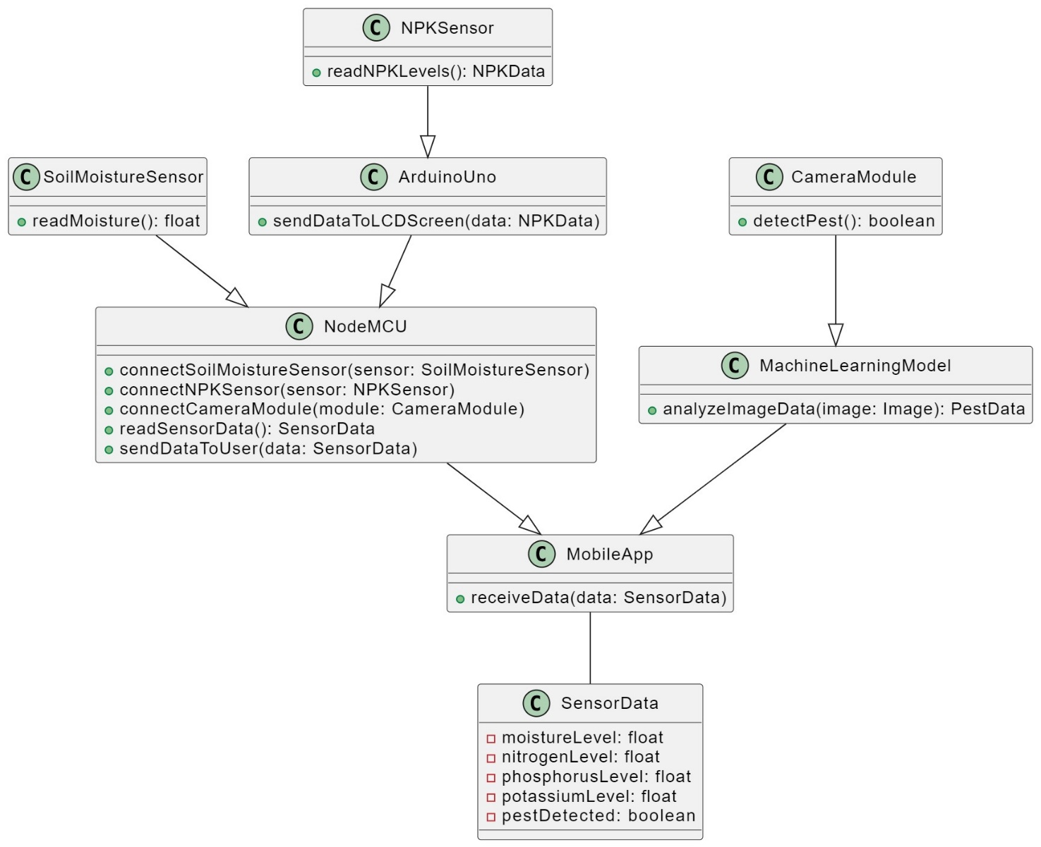**Fig 5.1 System architecture**